RESUME 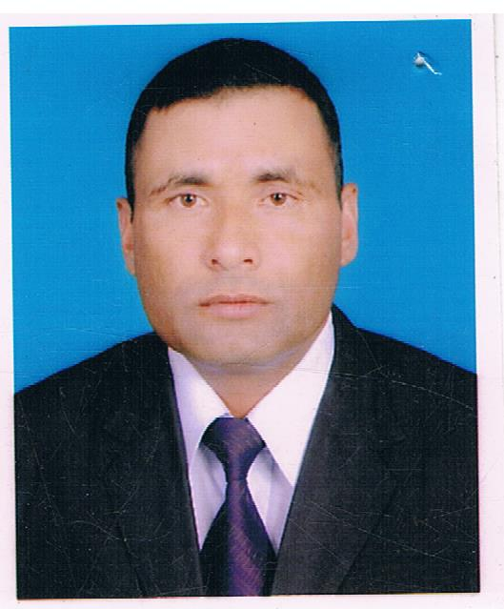
GOBINDA PAUDEL
(Gokarna-01, Kathmandu, Nepal
Kaski, Kalika-3, Pokhara, Nepal
00974-66331687 / 70198235
gobindapkr2006@gmail.com.

Application for: -
Security Guard, Guard Supervisor, C.C.TV .Operator camp boos, foreman, Housing , storekeeper, watchman, Driver, Salesman, and any kind of available work.

Objectives:-
I would like to utilize my special skills which will achieve the organizations as well as my personal growth.

Work Experience:
Military Experience—(Nepal Army) 1985 to 1999 – 14 Years.
Nepal Infantry Army, Duties Included, Army Basic, Weapons Trainer, Map Reading Training, Sections Leader, Platoon Leader, Military Police, Fire Fighting And Safety Security Special Security Force, Armor And First Aid Trainer.

Peacekeeping force of U.N 1998 to 1999- six months.
Peacekeeping as a part of Nepal Army Constringency, working security and safety mission in Lebanon.
Security Guard Since Feb- 06- 2000 to Jun 11 2009- 9 years.
Force protection specialist for DynCorp International Security Company (American Company), working on U.S Army Base camp Security Guard in Doha Qatar.

Relative Skills:-

People search processor, vehicles search processor, force protection, operator of Explosive Detection Units Ions can 500 and 400, operator of explosive detection Unite Itemizers, Operator of Personal X-Ray screening unite ( Rap scan Secure 1000) Operators of (UVSS) Under Vehicle Surveillance, Entry Control Point Security, Quick Reaction Force, Perimeter Security, Radio Processor, Welcome And Overview, Chain Of Command, Interpersonal communication, Protection of Personnel, Other & Vital Property, Equal Opportunity/Sexual Harassment, Fire Extinguisher, First Aid, Detain, Use of Force, Human Trafficking, Use of Duress Code, Incident Response, Suicide Bombers, Protected Restricted Area, Role of Engagement, Situation Reports, SOP.(Standard Operating Procedure), PDA (Personal Digital Assistant), DBIDS (Defense Biometrics Identification System), Recommendation and Award.

Weapons Qualifiations:-
• 7.62-SLR (Self Loading Rifle)
• 7.62-SMG,
• 7.62-LMG,
• 2’-Motor
• GPMG,
• 14.5-MM Anti Air Craft Gun,
• No. 36- Hands Grenades,
• M-16,A1 & A2 Rifle
• 9-MM, Pistols.

Computer skills:-
• E-mail and Internet
• Office Package
Language Skills:-
• Nepali
• English
• Hindi
• Little Arabic

Education:-
• Secondary School Leaving Certificate {S.L.C.Test Passed}.
• Army School – First Class Passed.

Personal Profile:-
• Name : Gobinda Paudel
• Date Of Birth: 04-03-1967
• Sex : Male
• Nationality : Nepali
• Passport No. : 06760437

Note: 8 years driving experience in Gulf Country (Qatar) and 10 years in Nepal.
I, the undersigned confirm applying at your organization with the help of this resume and agree that all the above provided information is true to the best of my knowledge.
Sincerely Yours,

…………………………
GOBINDA PAUDEL

